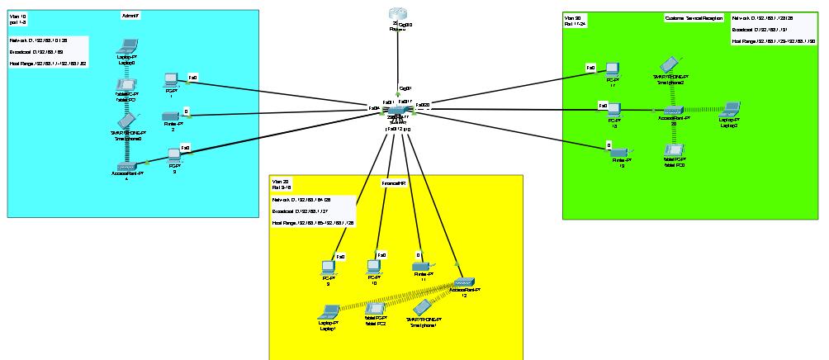

**XYZ company is a fast-growing company in Eastern Australia with more than 2 million customers globally. The company deals with selling and buying of food items, which are basically operated from the headquarters. The company is intending to open a branch near the local village Bonalbo. Thus, the company requires young IT graduates to design the network for the branch. The network is intended to operate separately from the HQ network. Being a small network, the company has the following requirements during implementation;**

1. **One router and one switch to be used (all CISCO products).**
2. **3 departments (Admin/IT, Finance/HR and Customer service/Reception).**
3. **Each department is required to be in different VIANS.**
4. **Each department is required to have a wireless network for the users.**
5. **Host devices in the network are required to obtain IPv4 address automatically.**
6. **Devices in all the departments are required to communicate with each other.**

**Assume the ISP gave out a base network of 192.168.1.0, you as the young network engineer who has been hired, design and implement a network considering the above requirements.**

**Technologies Implemented**

1. Creating a Simple Network using a Router and Access Layer Switch.

Router Model 2911

Access Layer Switch Model 2960-24TT

1. Connecting Networking devices with Correct cabling.

Copper Stright Wire

1. Creating VLANs and assigning ports VLAN numbers.

Vlan 10 (Admin/IT)

Vlan 20 (Finance/HR)

Vlan 30 (CS/Reception)

**Command in Switch**

Switch>

Switch>enable

Switch#

Switch#configure terminal

Switch(config)#

Switch(config)#interface range fastEthernet 0/1-8

Switch(config-if-range)#switchport mode access

Switch(config-if-range)#switchport access vlan 10

% Access VLAN does not exist. Creating vlan 10

Switch(config-if-range)#exit

Switch(config)#interface range fastEthernet 0/5-8

Switch(config-if-range)#shutdown

Switch(config)#

Switch(config)#interface range fastEthernet 0/9-16

Switch(config-if-range)#switchport mode access

Switch(config-if-range)#switchport access vlan 20

% Access VLAN does not exist. Creating vlan 20

Switch(config-if-range)#exit

Switch(config)#interface range fastEthernet 0/21-24

Switch(config-if-range)#shutdown

Switch(config)#

Switch(config)#interface range fastEthernet 0/17-24

Switch(config-if-range)#switchport mode access

Switch(config-if-range)#switchport access vlan 30

% Access VLAN does not exist. Creating vlan 30

Switch(config-if-range)#exit

Switch(config)#interface range fastEthernet 0/21-24

Switch(config-if-range)#shutdown

Switch(config)# do wr

Switch>enable

Switch#

Switch#configure terminal

Switch(config)#

Switch(config)#interface gigabitEthernet 0/1

Switch(config-if)#switchport mode trunk

Switch(config-if)#exit

Switch(config)#interface gigabitEthernet 0/2

Switch(config-if)#shutdown

1. Subnetting and IP Addressing.

255.255.255.192 == Subnet Mask

IP Range = 192.168.1.1-192.168.1.62

IP Range = 192.168.1.65-192.168.1.126

IP Range = 192.168.1.129-192.168.1.190

1. Configuring Inter-VLAN Routing (Router on a stick).

**Command in Switch**

Router>

Router>enable

Router#configure terminal

Router(config)#

Router(config)#interface gigabitEthernet 0/0

Router(config-if)#no shutdown

Router(config-if)#exit

Router(config)#interface gigabitEthernet 0/0.10

Router(config-subif)#encapsulation dot1Q 10

Router(config-subif)#ip address 192.168.1.1 255.255.255.192

Router(config-subif)#exit

Router(config)#interface gigabitEthernet 0/0.20

Router(config-subif)#encapsulation dot1Q 20

Router(config-subif)#ip address 192.168.1.65 255.255.255.192

Router(config-subif)#exit

Router(config)#interface gigabitEthernet 0/0.30

Router(config-subif)#encapsulation dot1Q 30

Router(config-subif)#ip address 192.168.1.129 255.255.255.192

Router(config-subif)#exit

Router(config)#do wr

1. Configuring DHCP Server (Router as the DHCP Server).

**Command**

Router#

Router#config terminal

Router(config)#service dhcp

Router(config)#ip dhcp pool Admin-pool

Router(dhcp-config)#network 192.168.1.0 255.255.255.192

Router(dhcp-config)#default-router 192.168.1.1

Router(dhcp-config)#dns-server 192.168.1.1

Router(dhcp-config)#domain-name Admin.com

Router(dhcp-config)#exit

Router(config)#

Router(config)#ip dhcp pool Finace-Pool

Router(dhcp-config)#network 192.168.1.64 255.255.255.192

Router(dhcp-config)#default-router 192.168.1.65

Router(dhcp-config)#dns-server 192.168.1.65

Router(dhcp-config)#domain-name Finance.com

Router(dhcp-config)#exit

Router(config)#

Router(config)#ip dhcp pool CS.com

Router(dhcp-config)#network 192.168.1.128 255.255.255.192

Router(dhcp-config)#default-router 192.168.1.129

Router(dhcp-config)#dns-server 192.168.1.129

Router(dhcp-config)#domain-name CS.com

Router(dhcp-config)#exit

Router(config)#do wr

1. Configuring WLAN or wireless network (Cisco Access Point).
2. Host Device Configurations.
3. Test and Verifying Network Communication.

**Subnetting**

Base Network: 192.168.1.0

No. of subnets: 3

No. of subnets: 2^n

2^n = 3 === n = 2

Class C = 255.255.255.0 11111111.11111111.11111111.00000000

After borrowing 2 bits

New Binary = 11111111.11111111.11111111.11000000

128 64 32 16 8 4 2 1

7 6 5 4 3 2 1 0

128 + 64 = 192

New subnets: 255.255.255.192

Block Size= 64

1st Subnets

Network ID: 192.168.1.0

Broadcast ID:192.168.1.63

Host Range:192.168.1.1-192.168.1.62

2nd Subnet

Network ID: 192.168.1.64

Broadcast ID:192.168.1.127

Host Range:192.168.1.65-192.168.1.126

3rd Subnet

Network ID: 192.168.1.128

Broadcast ID:192.168.1.191

Host Range:192.168.1.129-192.168.1.190